**Practice Data Analysis – Year 11 Chemistry Unit 1**

**Data Set**

The following table shows the properties of three mystery elements X, Y and Z.

|  |  |  |  |
| --- | --- | --- | --- |
| **Element** | **X** | **Y** | **Z** |
| **Appearance** | Yellow, shiny | Pale yellow, dull | Dull grey, semi-shiny |
| **Crushability** | Malleable | Brittle | Malleable |
| **Density (g/cm3)** | 19.4 | 2.07 | 7.10 |
| **Melting Point (°C)** | 1064 | 115 | 419 |
| **Boiling Point (°C)** | 2700 | 444 | 906 |
| **Conductivity** | Conductor as solid and liquid | Non-conductor as solid and liquid | Conductor as solid and liquid |
| **Electrical conductivity**  **(S / m)** | 4.1 × 107 | 5 × 10-18 | 1.6 × 107 |

1. **Classify** the elements into 2 groups. **Justify** your classifications. [4 marks]

To classify these mystery elements, the first group would be Y, and the second group would include X and Z because they share the most similarities in their properties. Appearance-wise, elements X and Z are shiny and semi-shiny respectively, contrasting with Y’s dull appearance. Y is brittle and has a lower density of 2.07 g/cm3, whereas X and Z are malleable and have higher densities (19.4g/cm3 for X, 7.10 for Z). In addition, both X and Z are electrically conductive in a solid and liquid state, a property absent from element Y. Overall, element Y’s standalone properties support its placement in a separate group, and elements X and Z’s commonalities justify their paired grouping.

**Data Set**

The following table shows the properties of three mystery substances X, Y and Z.

|  |  |  |  |
| --- | --- | --- | --- |
| **Substance** | **X** | **Y** | **Z** |
| **Melting Point (°C)** | 5.5 | 2266 | 419 |
| **Electrical Conductivity** | Non-conductor as solid and liquid | Non-conductor as solid  Moderate conductor as molten liquid | Good conductor as solid  Moderate conductor as molten liquid |

1. **Classify** the type of substance that X, Y and Z could be (ionic, covalent or metallic). **Justify** your classifications. [5 marks]

Substance X is likely a covalent substance, due to its very low melting point of 5.5°C and being a non-conductor in both solid and liquid state, properties characteristic of covalent bonds. Substance Y is ionic because it is a non-conductor as a solid but a moderate conductor as a molten liquid, a property seen only in ionic compounds. Substance Z being electrically conductive in both a solid and liquid state would indicate a metallic substance.

**Data Set**

A student tested 5 samples of solid substances; sand (mostly SiO2), zinc (Zn), charcoal (largely C), calcium chloride (CaCl2), citric acid (C₆H₈O₇). The results of their tests are shown below.

|  |  |  |  |  |  |  |
| --- | --- | --- | --- | --- | --- | --- |
| **Substance** | | **Approx. Melting Point (°C)** | **Solubility in Water** | **Lights up a light bulb** | | **Electrical conductivity of aqueous form (dS / m)** |
| **Number assigned** | **Name** | **Solid form** | **Aqueous form** |
| 1 | Citric acid | ~150 | Soluble | No | Yes | 1.3 |
| 2 | Zinc | ~400 | Insoluble | Yes | NA | NA |
| 3 | Charcoal | N | Insoluble | Yes | NA | NA |
| 4 | Calcium Chloride | N | Soluble | No | Yes | 7.8 |
| 5 | Sand (SiO2) | N | Insoluble | No | NA | NA |

Note: Melting point of N means the temperature was not hot enough to reach the melting point.

NA means not applicable to the substance.

1. Citric acid is a covalent simple molecular compound, not an ionic compound. **Identify** which property it has that is consistent with covalent but not ionic properties. [1 mark]

Citric acid’s low observed melting point of ~150°C is consistent with the low to moderate melting points of covalent substances, and conflicts with the high melting point of ionic substances.

1. Charcoal is a covalent lattice compound. **Identify** which main property it has that would be used to support its classification as a covalent lattice rather than a metal. [1 mark]

Charcoal’s inability to melt in the experiment (indicated by its “N” melting point) is uncharacteristic of metals, which have low melting points. This would indicate that charcoal is not a metal.

1. **Classify** each substance not already identified as metallic, ionic, covalent simple molecular or covalent giant molecular network. [3 marks]

Number 2 would likely be metallic due to it conducting in its solid form and being insoluble. Number 4 is ionic due to its high melting point and conductivity in its aqueous form but not solid. Number 5 is likely a covalent giant molecular network, since it is insoluble, does not conduct, and has a very high melting point.

1. Complete the missing substance names in the table and draw a **justified** **conclusion** as to the identity of each sample number. [6 marks]

Substance 2 – Zinc: Is the only metal element tested, has a low melting point of ~400 C and conducts in its solid form due to the presence of delocalized electrons.

Substance 4 – Calcium Chloride: Composed of a positively charged metal (Calcium) bonded to a negatively charged nonmetal (Chlorine).

Substance 5 – Sand (SiO2): Composed of two nonmetals with electronegativities too high to form ionic bonds.

**Data Set**

A student tested some properties of various ionic and covalent compound samples. The results of their tests are shown below.

|  |  |  |  |  |  |  |
| --- | --- | --- | --- | --- | --- | --- |
| **Substance** | **Type of bonding** | **State at room temperature** | **Melting point (°C)** | **Dissolves in water** | **Electrical conductivity (lightbulb)** | |
| **Solid form** | **Dissolved in water** |
| Distilled water (H2O) | Covalent | Liquid | 0 | N/A | N/A |  |
| Sodium chloride (NaCl) | Ionic | Solid | 808 | Yes | No |  |
| Potassium iodide (KI) | Ionic | Solid | 680 | Yes | No |  |
| Sucrose (C12H22O11) | Covalent | Solid | 186 | Yes | No |  |
| Olive oil | Covalent | Liquid | -6 | No | N/A | N/A |
| Ethanol (C2H5OH) | Covalent | Liquid | -114 | Yes | N/A |  |
| Corn starch | Covalent | Solid | Decomposes at high temperatures | No | No | N/A |
| Glycerin | Covalent | Liquid | 290 | No | N/A |  |

Note: N/A means not applicable to the substance.

1. For the substances whose type of bonding is listed, **identify** whether there is a clear relationship between the type of compound bonding and its state at room temperature or not. [1 mark]

There is no clear relationship.

1. **Justify** your choice for the previous question. [1 mark]

Only one Ionic substance is identified, and the covalent substances differ from solid to liquid.

1. For the substances whose type of bonding is listed, **identify** whether covalent compounds are generally soluble in water or not. [1 mark]

The identified substances show that covalent compounds tend to be not soluble in water but can be in some cases (sucrose).

1. Sucrose is a covalent compound, not an ionic compound. **Identify** which properties it has that is consistent with covalent but not ionic properties. [1 mark]

Sucrose does not contain any metal ions and has a lower melting point than is typical of ionic compounds.

1. **Classify** the type of bonding as ionic or covalent for the substances not completed. [2 marks]
2. **Justify** the classifications for the previous question answer. [2 marks]

Potassium Iodide – Ionic: Contains a metal cation bonded to a nonmetal anion, has a high-ish melting point, is water-soluble, and is conductive in an aqueous state.

Ethanol – Covalent: Shares properties with other covalent liquids.

**Data Set**

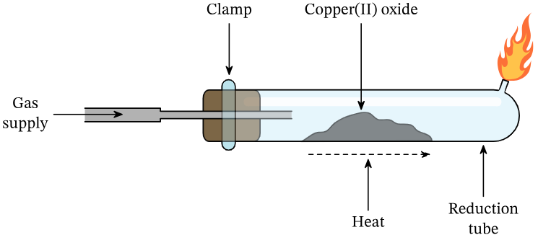

excess gas burned off

with bung

test

Figure 1: Experimental set up for reducing copper oxide

As shown in Figure 1, a practical was done where copper (II) oxide powder is heated in a glass tube while passing the gas methane over it, reducing the copper (II) oxide to copper.

The purpose of the practical was to determine the empirical formula of copper oxide. The masses before and after the reduction were measured, with results shown in in Table 1.

The theoretical reduction reaction is 4 CuO (s) + CH4 (g) à 4 Cu (s) + 2H2O (g) + CO2 (g)

Table 1: Trial results for reducing copper oxide

|  |  |  |  |  |  |  |  |  |  |  |
| --- | --- | --- | --- | --- | --- | --- | --- | --- | --- | --- |
| **Trial number** | **Mass ± 0.01 (g)** | | | | | | **Moles (mol)** | | **Experimental mole ratio**  **Cu : O** | |
| **Test tube with bung** | **Test tube with bung + copper oxide** | **copper oxide** | **Test tube with bung + product copper (Cu)** | **copper (Cu)** | **oxygen (O)** | **copper (Cu)** | **oxygen (O)** |
| **decimal** | **simplest whole number** |
| 1 | 6.00 | 7.76 | 1.76 | 7.43 | 1.43 | 0.33 | 0.0225 | 0.0206 | 1.0909 : 1 | 1 : 1 |
| 2 | 6.00 | 7.71 | 1.71 | 6.61 | 0.61 | 1.1 | 0.0096 | 0.0688 | 1 : 7.1667 | 1 : 7 |
| 3 | 6.00 | 7.70 | 1.70 | 7.45 | 1.45 | 0.25 | 0.0228 | 0.0156 | 1.4615 : 1 | 3 : 2 |
| 4 | 6.00 | 7.68 | 1.68 | 7.40 | 1.40 | 0.28 | 0.0220 | 0.0175 | 1.2589 : 1 | 5 : 4 |
| Average (excluding anomalous trial) | 6.00 | 7.71 | 1.71 | 7.43 | 1.43 | 0.29 | 0.0225 | 0.018 | 1.2413 : 1 | 5 : 4 |

1. **Identify** the anomalous trial result by circling it in the table above. [1 mark]
2. **Calculate** the average mass of the copper and oxygen excluding the anomalous trial result. [2 marks]
3. Using Trial 3’s experimental data provided in Table 1 and the formula *n = m/M*, **calculate** the number of moles of copper (Cu) and oxygen atoms (O) involved in the trial’s reaction. [4 marks]
4. Using your answers from the previous question, **calculate** the experimental mole ratio between copper and oxygen for Trial 3’s run.

From this, **determine** the experimental empirical formula for copper oxide for Trial 3. [3 marks]

Cu3O2

1. The theoretical empirical formula of copper oxide is CuO.

**Sequence** Group 1 and 4’s experimental results from the least to most accurate. [1 mark]

1. Trial 1 – 1 : 1, CuO
2. Trial 4 – 5 : 4, Cu5O4
3. Trial 3 – 3 : 2
4. Trial 2 – 1 : 7
5. **Infer** one experimental error which could have contributed to the experimental mole ratio obtained by Group 2. [1 mark]

**Data Set**

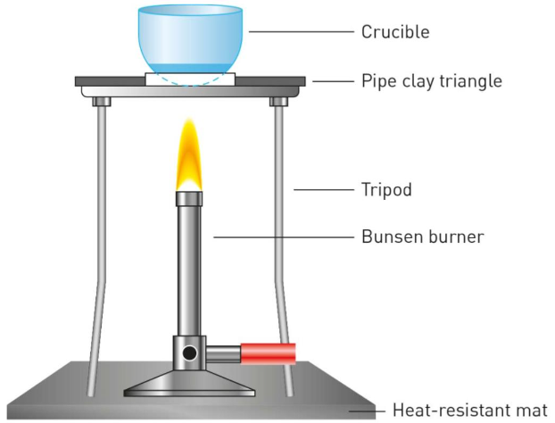

Figure 1: Experimental set up for heating magnesium

A practical was done where a curled piece of magnesium ribbon underwent a combustion reaction with excess oxygen from the air in a heated crucible as shown in Figure 1.

The purpose of the practical was to determine the empirical formula of magnesium oxide, the mole ratio for the synthesis reaction of magnesium oxide and to determine the yield of magnesium oxide when using the theoretical empirical formula. The masses before and after the oxidation were measured. The many group’s results are shown in Table 1.

The theoretical synthesis reaction is 2 Mg (s) + O2 (g) à 2 MgO (s)

Table 1: Group results for burning magnesium ribbon

|  |  |  |  |  |  |  |  |  |  |  |  |  |  |  |  |  |
| --- | --- | --- | --- | --- | --- | --- | --- | --- | --- | --- | --- | --- | --- | --- | --- | --- |
| **Group Number** | **Mass ± 0.001 (g)** | | | | | | **Moles (mol)** | | | **Experimental mole ratio** | | | | | | |
| **Crucible** | **Crucible + Mg** | **Mg** | **Crucible + product magnesium oxide** | **O** | **product magnesium oxide (assume MgO)** | **Mg** | **O** | **product magnesium oxide (assume MgO)** | **Mg : O** | | | **Mg : MgO** | | |
| **decimal** | **simplest whole number** | **decimal** | | **simplest whole number** |
| 1 | 25.625 | 25.682 | 0.057 | 25.703 | 0.021 | 0.078 | 0.0023 | 0.00131 | 0.0019 | 1.7557 : 1 | 7 : 4  ~2 : 1 | 1.21 : 1 | | 6 : 5  ~1 : 1 |
| 2 | 24.018 | 24.091 | 0.073 | 24.121 | 0.003 | 0.103 | 0.0030 | 0.00019 | 0.0026 | 15.8046 : 1 | 63 : 4  ~16 : 1 | 1.15 : 1 | | 1 : 1 |
| 3 | 23.520 | 23.570 | 0.050 | 23.610 | 0.040 | 0.090 | 0.0021 | 0.00250 | 0.0022 | 1.1905 : 1 | 6 : 5  ~1 : 1 | 1 : 0.92 | | 1 : 1 |
| 4 | 24.520 | 24.590 | 0.060 | 24.600 | 0.020 | 0.080 | 0.0025 | 0.00125 | 0.0020 | 2 : 1 | 2 : 1 | 1.26 : 1 | | 5 : 4  ~1 : 1 |
| 5 | 25.190 | 25.490 | 0.300 | 25.300 | -0.190 | 0.110 | 0.0123 |  | 0.0027 |  |  | 4.52 : 1 | | 9 : 2 |
| 6 | 25.770 | 25.830 | 0.060 | 25.840 | 0.010 | 0.070 | 0.0025 | 0.00063 | 0.0017 | 3.9683 : 1 | 4 : 1 |  | |  |
| 7 | 27.600 | 27.696 | 0.096 | 23.060 | -4.636 | -4.54 | 0.0039 |  | 0.0015 |  |  |  | |  |

1. **Identify** the group(s) with O mass results that are impossible by circling it/them in the table above. [1 mark]
2. Using Group 4’s experimental data provided in Table 1 and the formulas *mass of O = (mass of Crucible + product magnesium oxide) – (mass of Crucible + Mg)*

and *n = m/M*, **calculate** the number of moles of oxygen atoms (O) consumed by their Group. [3 marks]

1. Using the data provided in Table 1 for Group 4’s experiment, and your answer from the previous question, **calculate** the experimental mole ratio between magnesium and oxygen.

From this, **determine** the experimental empirical formula for magnesium oxide. [3 marks]

Mg2O

1. The theoretical empirical formula of magnesium oxide is MgO. **Sequence** Group 1, 2 and 3’s experimental results from the least to most accurate in regards to empirical formula determination. [1 mark]
2. **Infer** one experimental error which could have contributed to the experimental mole ratio obtained by Group 2. [1 mark]
3. Using Group 6’s experimental data provided in Table 1 and the formulas *mass of product magnesium oxide (assume MgO) = (mass of Crucible + product magnesium oxide) – (mass of Crucible)* and *n = m/M*, **calculate** the number of moles of product magnesium oxide (assume MgO) produced by their Group.

[3 marks]

1. Using the data provided in Table 1 for Group 6’s experiment, and your answer from the previous question, **calculate** the decimal experimental mole ratio between magnesium and magnesium oxide for the synthesis reaction.

From this, **determine** the simplest whole number experimental Mg : MgO mole ratio determination. [3 marks]

1. The theoretical mole ratio between Mg and MgO in the synthesis reaction is 2 : 2 = 1 : 1. **Sequence** Group 1, 2 and 3’s experimental results from the most to least accurate in regards to Mg : MgO mole ratio determination. [1 mark]
2. Using the data provided in Table 1 for Group 6’s experiment, and the formula *n = m/M*, **determine** the theoretical yield of magnesium oxide for the synthesis reaction. Recall that oxygen is assumed to be in excess. [2 marks]

Theoretical yield =

1. Using your answer from the previous question and another earlier question answer, **calculate** the percentage yield. [1 mark]

**Data Set**

A practical was conducted to determine the enthalpy changes (ΔH) of chemical reactions by calorimetry. The set up used is shown in Figure 1. The temperatures were measured after 2 min of stabilising the temperature after the reaction.

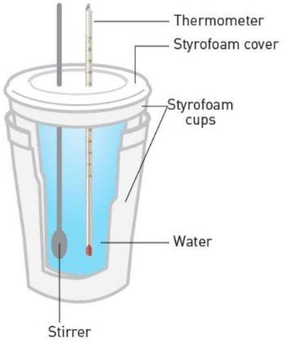

*Figure 1: Calorimeter set up*

The results of the calorimetry practical are shown in the table below.

The reactions investigated are shown below:

Part A (neutralisation reaction): HCl (aq) + NaOH (aq) à NaCl (aq) + H2O (l) ΔH = -58 kJ/mol

Part B (acid + metal oxide): 2HCl (aq) + MgO (s) à MgCl2 (aq) + H2O (l) ΔH = -146 kJ/mol

Part C (acid + metal carbonate): 2HCl (aq) + MgCO3 (s) à MgCl2 (aq)  + CO2 (g) + H2O (l) ΔH = -90 kJ/mol

Part D (displacement reaction): CuSO4 (aq) + Zn (s) à Cu (s) + ZnSO4 (aq) ΔH = -217 kJ/mol

|  |  |  |  |  |  |  |  |  |  |  |  |  |
| --- | --- | --- | --- | --- | --- | --- | --- | --- | --- | --- | --- | --- |
| **Part** | **Reactants** | **Reactant mole ratio** | **Limiting reagent** | **Volume of water solution (mL)** | **Temperature (° C)** | | | | **Observations** | **Energy change with reaction, Q (kJ)** | **Experimental ΔH (kJ/mol)** | **% error** |
| **Room** | **Before reaction** | **After reaction** | **Change** |
| A | 50mL 2M HCl (0.1 mol) + 50mL 2M NaOH (0.1 mol) | HCl : NaOH  1 : 1 | None | 100 | 24 | 24 | 39 | +15 | Fast reaction |  | -62.7 | 8% |
| B | 50mL 2M HCl (0.1 mol) + 0.9g MgO (0.0233 mol) | HCl : MgO  2 : 1 | MgO | 50 | 24 | 38 | +14 | Slow reaction | 2.93 |  | 14% |
| C | 50mL 2M HCl (0.1 mol) + 3.5g MgCO3 (0.0415 mol) |  |  |  |  | 32 | +8 | Medium reaction | 1.67 | -40.3 | 55% |
| D | 25mL 1M CuSO4 (0.025 mol) + 6.0g Zn powder ( _______ mol) | CuSO4 : Zn  1 : 1 | CuSO4 | 25 | 24 | 60 |  | Fast reaction | 37.62 | -409.9 |  |

1. **Calculate** the volume of water solution for Part C. [1 mark]

50mL

1. **Calculate** the temperature before the reaction for Part C. [1 mark]

24

1. **Calculate** the change in temperature for Part D. [1 mark]

+36

1. **Identify** the reaction Part with the largest change in temperature. [1 mark]

Part D

1. **Calculate** the energy change with the reaction for Part A. [2 marks]

6.27

1. **Calculate** the experimental ΔH for Part B. [2 marks]

-2.93/0.0233 =~ -126

1. **Calculate** the number of moles of Zn powder for Part D. [2 marks]

6.0/65.4 =~ 0.0917

1. **Identify** the reactant mole ratio and **determine** the limiting reagent for Part C. [3 marks]

2 : 1, Limiting reagent = MgCO3

1. **Calculate** the percent error of ΔH for Part D. [1 mark]

**Data Set**

A practical was conducted to determine the heat of neutralisation of the reaction between 0.05 mol of acetic acid and 0.05 mol of sodium hydroxide using a calorimeter. The reaction investigated was CH3COOH (aq) + NaOH (aq) à CH3COONa (aq) + H2O (l) ΔH = -55 kJ/mol

The results of the practical are shown in the table below.

|  |  |  |  |  |  |  |
| --- | --- | --- | --- | --- | --- | --- |
| **Density of solution (g mL–1) (product)** | **Density of water (g mL–1)** | **Volume of solution (water) ± 1 (mL)** | **Mass of solution (water) ± 1 (g)** | **Change in Temperature ± 1 (°C)** | | |
| **Trial 1** | **Trial 2** | **Trial 3** |
| 1.017 (CH3COONa) | 1.00 | 100.0 |  | 3.2 | 6.5 | 12.3 |

1. **Calculate** the average change in temperature. [1 mark]

(3.2+6.5+12.3)/3=7.33

1. **Calculate** the absolute uncertainty of the mean for the change in temperature. [1 mark]
2. **Calculate** the percentage uncertainty of the mean for the change in temperature. [1 mark]
3. Draw a **justified conclusion** about the reliability of the change in temperature measurements.

[2 marks]

1. **Determine** the mass of solution (water). [1 mark]
2. **Calculate** the energy change for the reaction. [2 marks]
3. Draw a **justified conclusion** about what assumption(s) being made in the calculation of Q could be contributing to a less valid value being determined.

[2 marks]

1. **Calculate** the experimental ΔH for the reaction. [2 marks]
2. **Calculate** percent error of ΔH for the reaction. [1 mark]
3. Draw a **justified conclusion** about the validity of the practical by considering the ΔH values and process of calorimetry.

[4 marks]

**Dataset**

An experiment was conducted to investigate the quantitative relationships among reactants and products for the reaction of ammonia with oxygen. Graph 1 shows the molar amounts of the species of the reaction and Graph 2 shows the masses of the reactants.

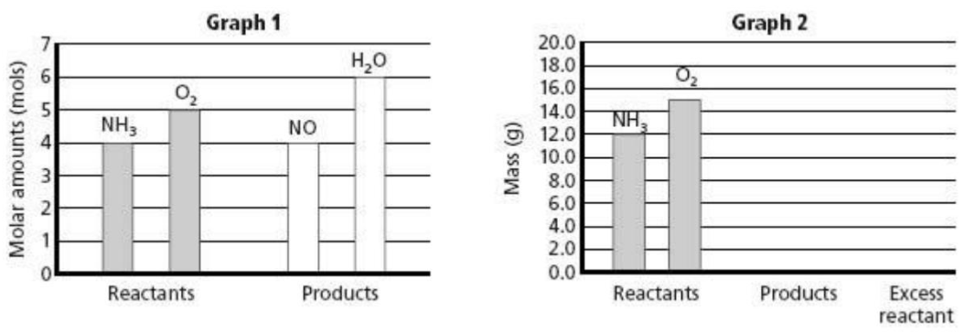

1. **Deduce** the balanced chemical equation for the reaction of ammonia and oxygen forming nitrogen oxide and water. [1 mark]
2. **Calculate** the difference in reactant masses. [1 mark]
3. **Deduce** with justification the identity of the limiting reactant. [2 marks]

**Dataset**

An experiment was performed where varying masses of sodium (Na) solid metal were reacted with a fixed mass of chlorine gas (Cl2). The mass of the synthesised product sodium chloride (NaCl) was measured. The results are shown in the graph below.

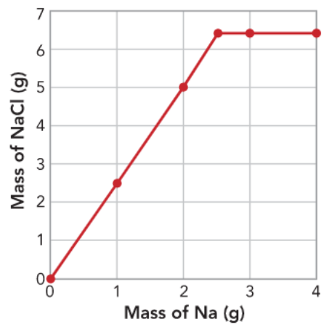

1. **Identify** the relationship between the mass of Na that reacted and the mass of NaCl produced prior to the graph flattening. [1 mark]

A direct positive relationship where each 1 gram of Na produces ~2.5g of NaCl.

1. **Identify** how many grams of Na were needed to be added to have 5 g of NaCl produced. [1 mark]

2 grams.

1. **Identify** the mass of NaCl produced when 1 g of Na reacted. [1 mark]

2.5 grams.

1. **Identify** the relationship between the mass of Na and the mass of NaCl at the plateau.

[1 mark]

Above about 2.5g of Na, there is no visible relationship between the two masses, as increasing the Na mass creates no change in the resulting mass of NaCl.

1. Draw a **justified conclusion** about why the graph flattens out after 2.5 g of sodium reacted.

[2 marks]

The flattening of the graph above 2.5g of Na indicates that it is no longer the limiting reagent of the reaction, and instead the fixed mass of Chlorine gas is limiting the extent of the reaction.

1. The theoretical yield of NaCl produced for the flattened-out section of the graph was 6.35 g. The actual yield shown was 6.3 g. **Calculate** the percentage yield. [1 mark]
2. **Infer** what the mass of NaCl produced would have been if 5 g of Na was reacted. [1 mark]

**Data Set**

An experiment was conducted to investigate limiting and excess reagents. Various amounts of iron, Fe, were added to liquid bromine, Br2, and the resulting solid iron (III) bromide, FeBr3, mass was measured and recorded. The results are shown in Graph 1 below.

The reaction proceeds according to the following equation: 2Fe (s) + 3Br2 (aq) → 2FeBr3 (s)

Graph 1: Results of iron and bromine reaction with varying masses

1. **Identify** the relationship between mass of iron and mass of product for the experiment.

[2 marks]

1. **Identify** the mass of iron which produced the maximum product before the graph plateaus (ie. flattened out section of the graph). [1 mark]
2. Estimate the mass of iron that produced 8g of FeBr3**.**  [1 mark]
3. Draw a **justified conclusion** about why the graph plateaus after 2 g of Fe reacted. [2 marks]
4. **Calculate** the percentage yield for the plateau of the graph if the theoretical yield of FeBr3 was 15 g. [2 marks]

**Dataset**

An experiment was performed where the atomic and ionic radii (pm) of some elements were measured and recorded. The results are shown in the diagram below.

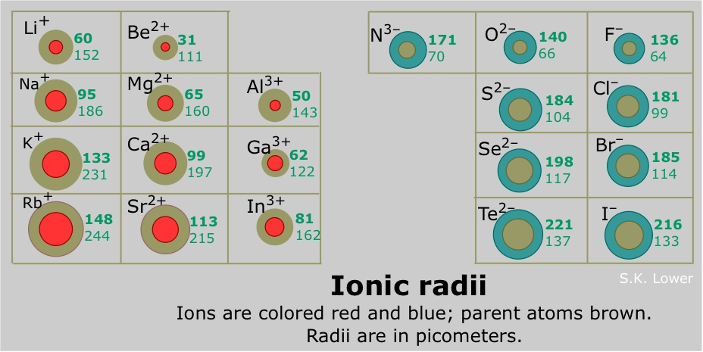

1. **Identify** the element with the smallest atomic radius. [1 mark]
2. **Identify** the element with the largest ionic radius. [1 mark]
3. **Calculate** the difference in atomic radius of Li and F. [1 mark]
4. **Identify** the relationship between the atomic radius and ionic radius as you go down a group. [1 mark]
5. **Identify** the trend for atomic radius across a period. [1 mark]
6. **Contrast** the trends in the change from atomic to ionic radii of period 3 metals and non-metals as you go across the period. [2 marks]
7. Provide a **justified deduction** as to whether the atomic or ionic radius would be the larger for the element Caesium (Cs) with the atomic number 55. [2 marks]
8. **Infer** an approximate numerical value range for the ionic radius of the element Astatine (At) with the atomic number 85, giving a reason for your answer. [2 marks]
9. Provide a **justified conclusion** as to why the Noble Gases were not able to have data obtained or provided. [2 marks]

**Dataset**

The successive ionisation energies of some unidentified elements were measured by photo-electron spectroscopy, in which light of a wavelength is directed at an atom, causing an electron to be ejected. The results for some elements are shown in Table 1 and another element in Graph 1 below.

Table 1: Results of successive ionisation energy measurements for elements

|  |  |  |  |  |  |  |  |  |  |
| --- | --- | --- | --- | --- | --- | --- | --- | --- | --- |
| **Ionisation number** | | 1 | 2 | 3 | 4 | 5 | 6 | 7 | 8 |
| **Ionisation energy (kJ mol-1)** | Element X in period 2 | 1314 | 3388 | 5301 | 7469 | 1089 | 13 327 | 71 337 | 84 080 |
| Element Y | 734 | 1450 | 7750 | 10 540 |  |  |  |  |
| Element Z in period 2 | 899 | 1757 | 14 850 | 21 005 |  |  |  |  |

Graph 1: Results of successive ionisation energy measurements for an element

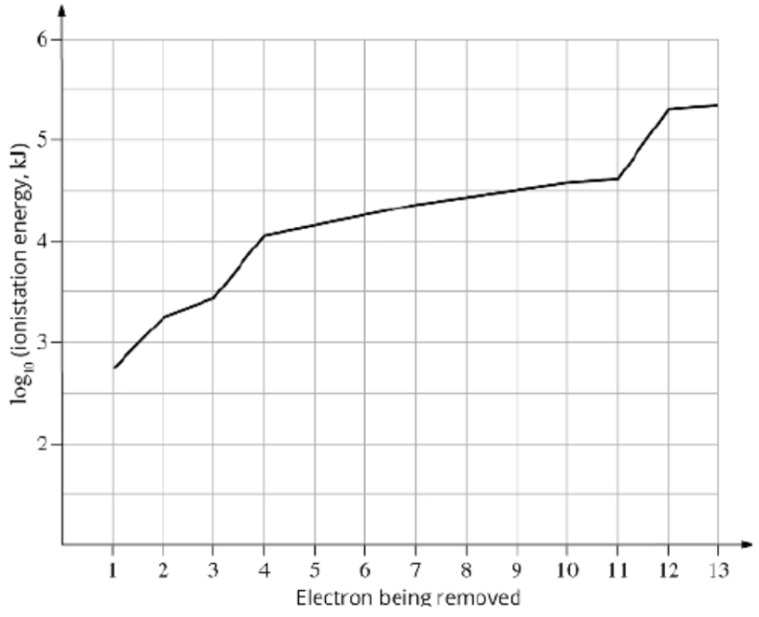

1. **Deduce** which group of the periodic table of elements you would expect to find element Z from Table 1. [1 mark]
2. **Deduce** the electron configuration of element Z from Table 1. [1 mark]
3. **Deduce** the minimum number of electrons element Y from Table 1 must have. [1 mark]
4. Provide a **justified deduction** as to the identity of element X from Table 1. [3 marks]
5. Provide a **justified deduction** of which element the data in Graph 1 is from. [3 marks]

**Data Set**

An experiment was performed where the atomic radius and electronegativity values of some elements were measured and recorded. The results are shown in Figure 1 and 2 below.

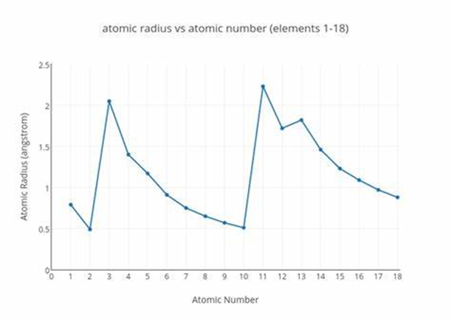

Figure 1: Atomic radius for the first 18 elements of the Periodic Table

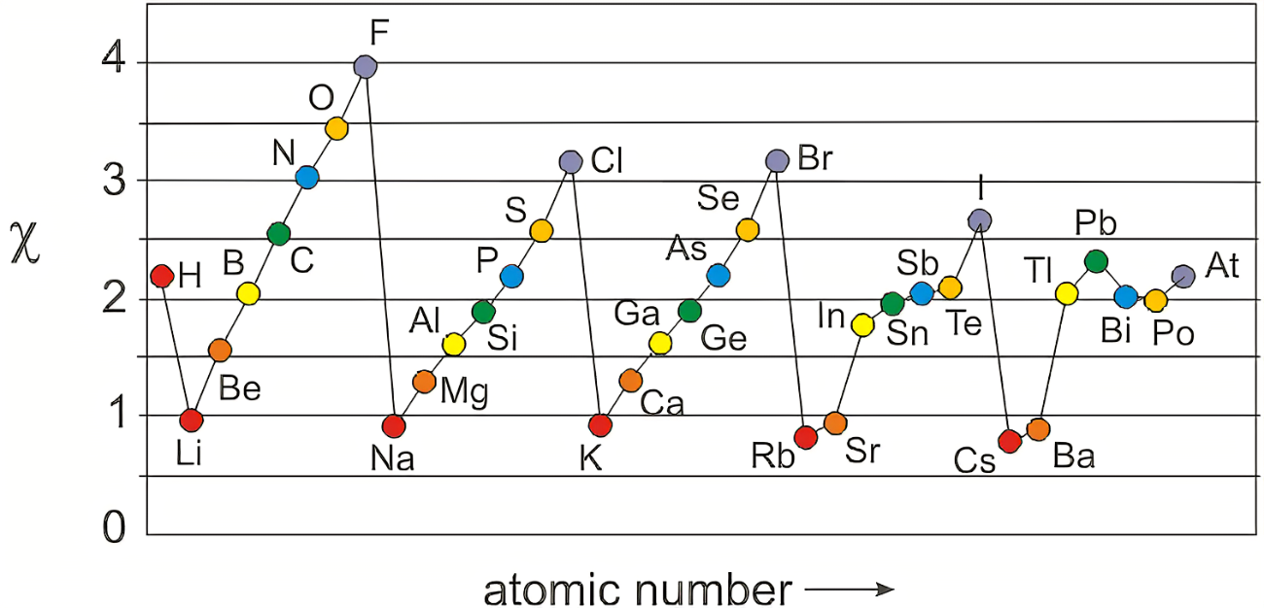

Electronegativity

Figure 2: Electronegativity for some elements of the Periodic Table

1. **Identify** which element has the highest atomic radius from Figure 1. [1 mark]
2. **Identify** which element has the highest electronegativity from Figure 2. [1 mark]
3. **Calculate** the difference in electronegativity between F and O. [1 mark]
4. **Identify** which element group on the Periodic Table generally has the lowest electronegativity on Figure 2. [1 mark]
5. **Identify** the element that does not follow the general trend identified in the previous question by circling the data point on Figure 2. [1 mark]
6. **Identify** the overall trend for electronegativity across period 2 in the Periodic Table from Figure 2. [1 mark]
7. **Identify** the relationship between atomic radius and electronegativity down Group 7/17 (Halogens) in the Periodic Table. [1 mark]
8. Draw a **justified conclusion** as to why the relationship identified in the previous question exists. [2 marks]
9. **Infer** an approximate numerical value range for the atomic radius for the element Potassium, K (atomic number 19), giving a reason for your answer. [2 marks]
10. **Infer** an approximate numerical value range for the electronegativity for the alkali metal Francium, Fr (atomic number 87), giving a reason for your answer. [2 marks]
11. Draw a **justified conclusion** why the Noble Gases (Group 8/18) are not present in Figure 2.

[2 marks]

**Dataset**

The successive ionisation energies for 3 known elements were gathered from simulation data. These were bromine (Br), calcium (Ca) and potassium (K).

The results are in the table below.

|  |  |  |  |  |
| --- | --- | --- | --- | --- |
| Element | Ionisation energy (kJ/mol) | | | |
| First | Second | Third | Fourth |
| 1 | 500 | 3500 | 4800 | 5900 |
| 2 | 600 | 1200 | 5500 | 6600 |
| 3 | 1200 | 2100 | 3500 | 4600 |

1. **Deduce** the identify of each known element (ie. which is 1, 2, 3). [3 marks]
2. Using the data in the table and the electron configuration of Mg (atomic number 12), make a **justified** **inference** as to which difference between successive ionisation energies would be the largest increase. [3 marks]

**Dataset**

The bromine saturation test was conducted with various compounds. Bromine water, Br2 (aq), was

added to a test compound and it was observed if the brown-orange persisted or was removed. The results are shown in the table below.

|  |  |  |  |  |
| --- | --- | --- | --- | --- |
| **Test compound** | methyl propane | propane | propene | methyl cyclohexene |
| **Test with bromine water** | no change | no change | decolourises | decolourises |

1. **Identify** the compound(s) that did not react. [1 mark]
2. **Classify** the compounds into 2 categories based on their structure and test result. [2 marks]
3. **Infer** the test result for butane. [1 mark]

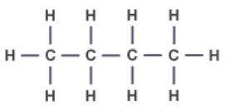

1. Provide a **justified deduction** as to the test result for cyclopentene. [2 marks]

